Documentation of News Systems

1. Summarize about News manager.
2. Home page

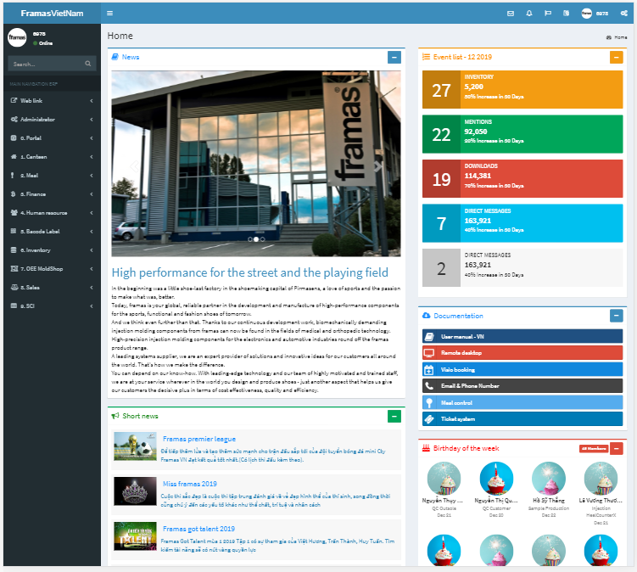

* Note

+ Website address: http://192.168.180.114:8888+ Username: input your employee number+ Password: default password is Framas.1In there, the system will be showing list announce such as News, event list, sort news and so on

* News

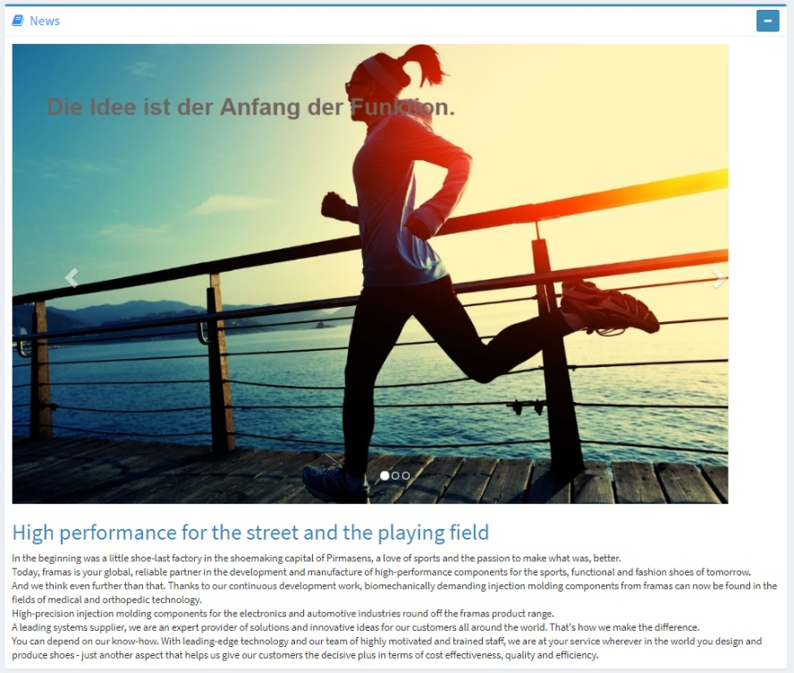

* Sort news

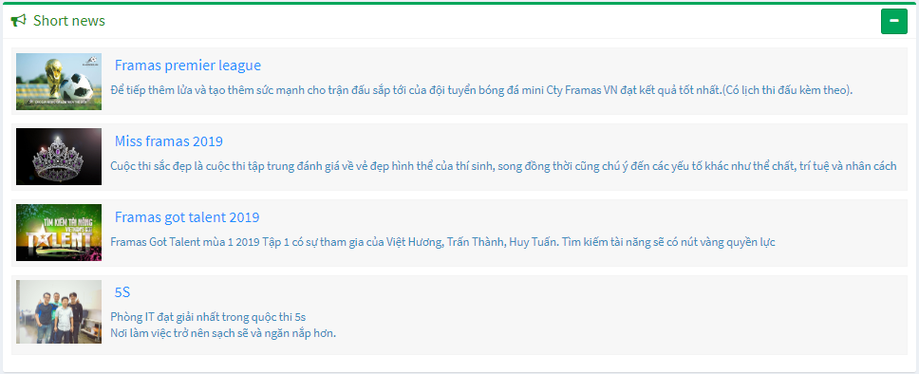

* Event list

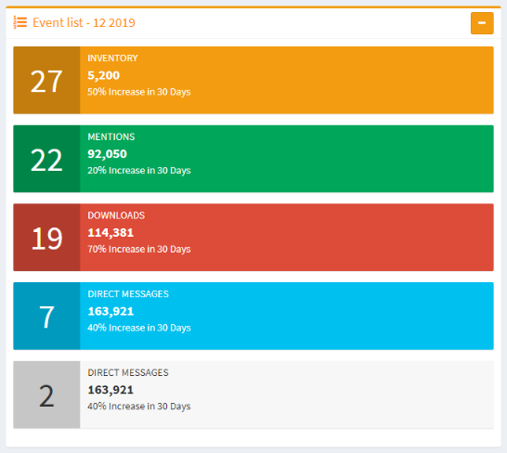

* Documentation

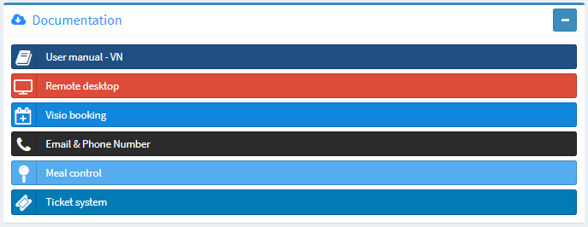

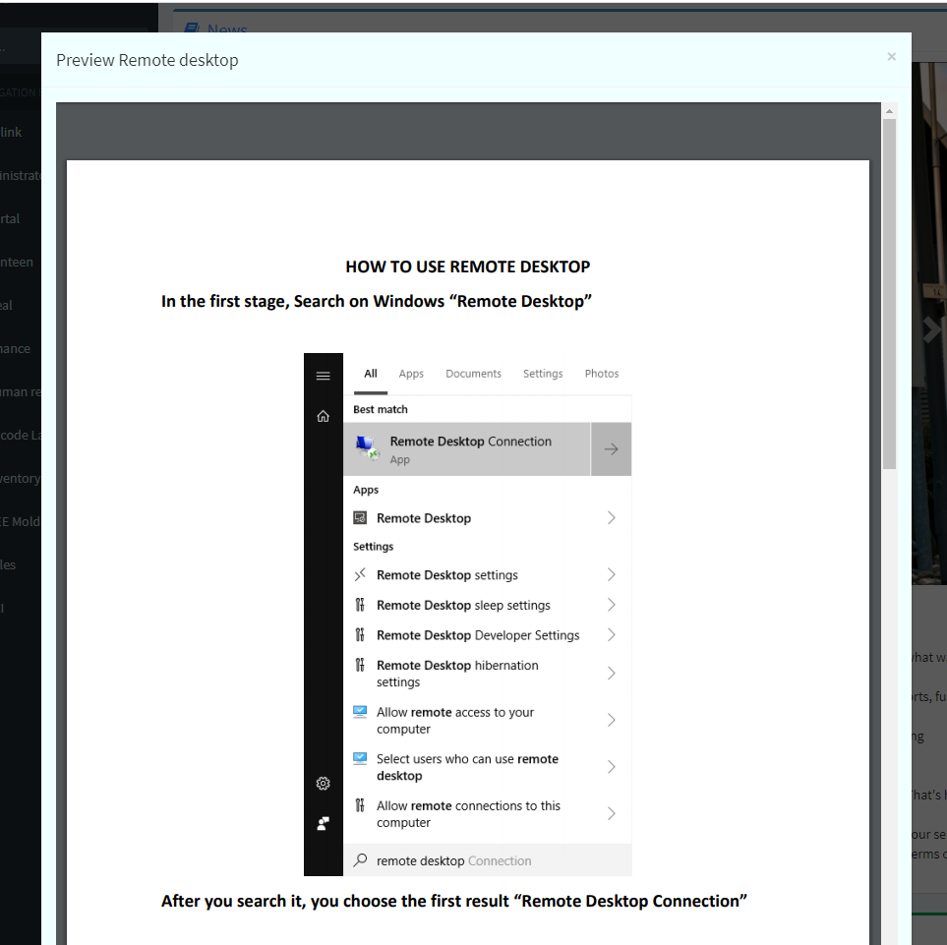

* Birthday of week

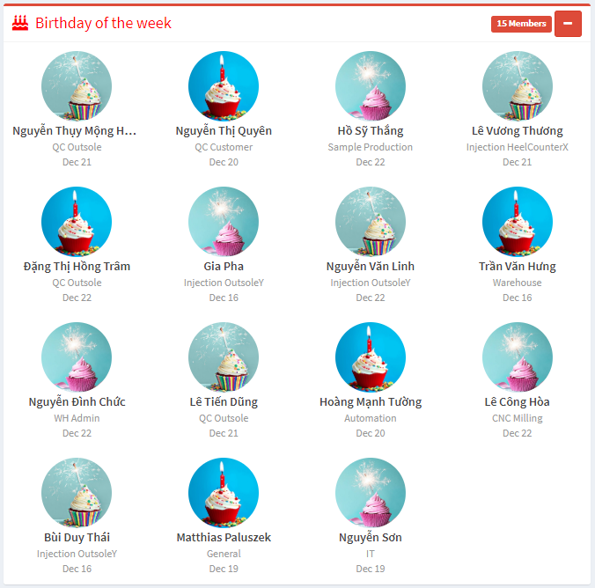

1. How can I manager
2. Login

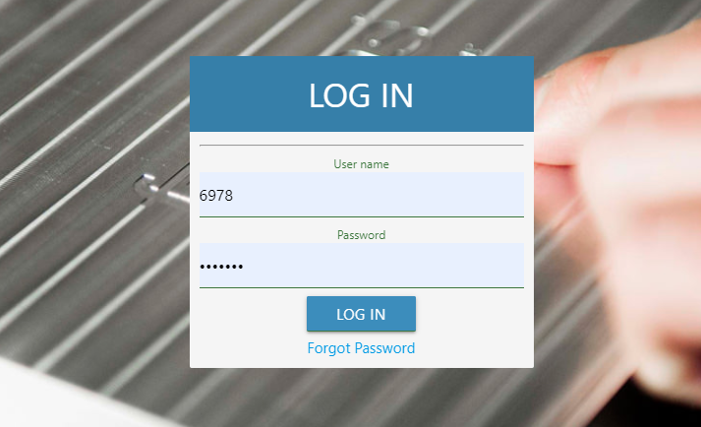

* Input employee number and password and click login
* After that, the system will be going to Home page

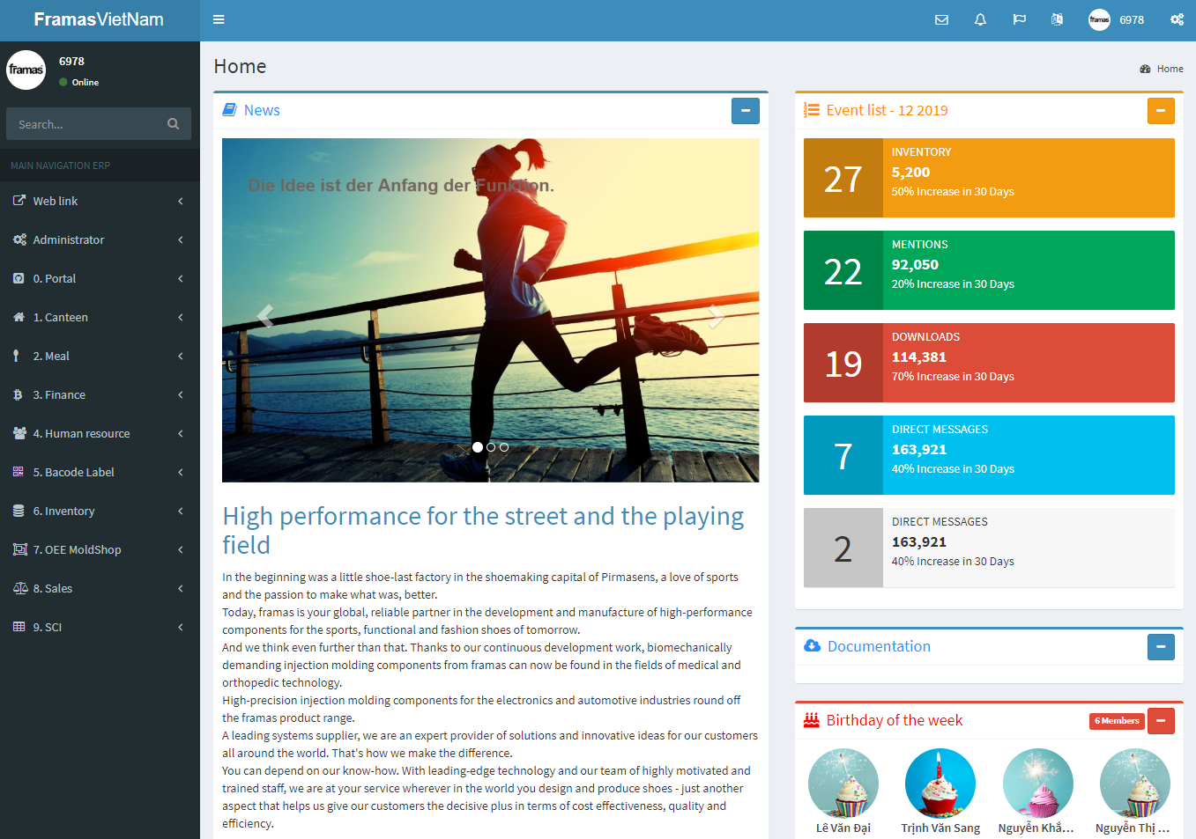

In this page look at the sidebar, the sidebar will be show a lot of module such as Admin, Portal,

Canteen, Human resource, Inventory so on correspondent with department list at Faramas.

Choose Human resource module and click News manager, after that system will be shown

Function list such as Documentation, Event, News, Slither

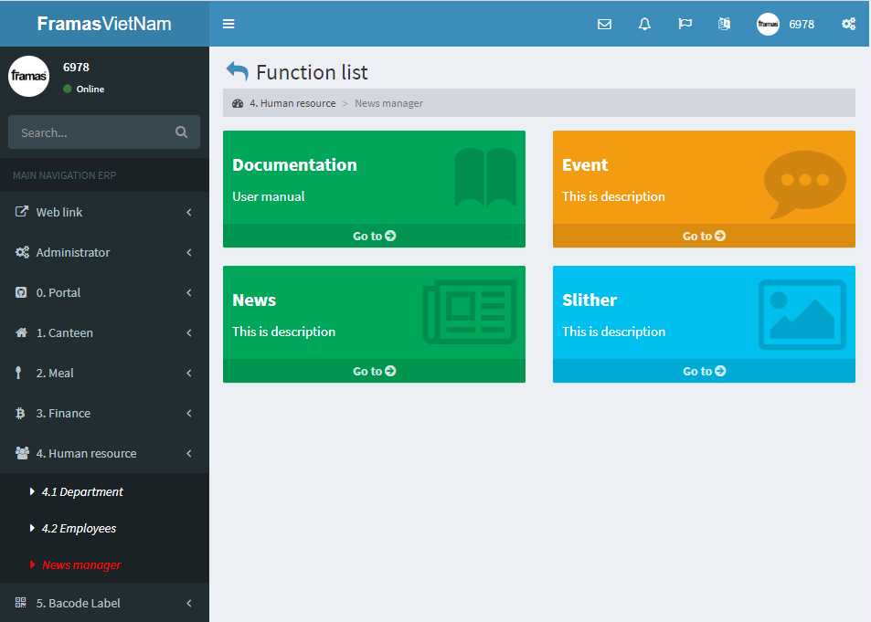

1. Document

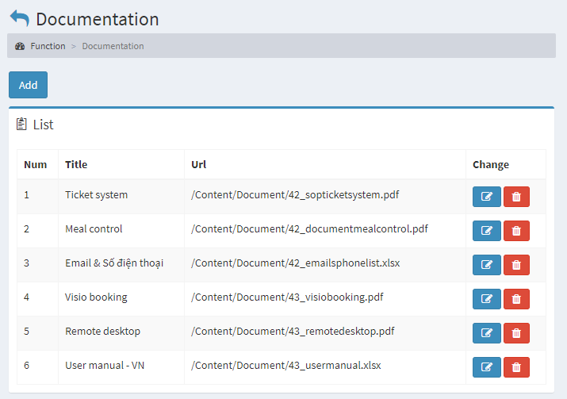

In there, the system will be showing all document list and you can add new, update or delete data

* Add new: click Add button

Input name, icon, file so on, click Save to complete

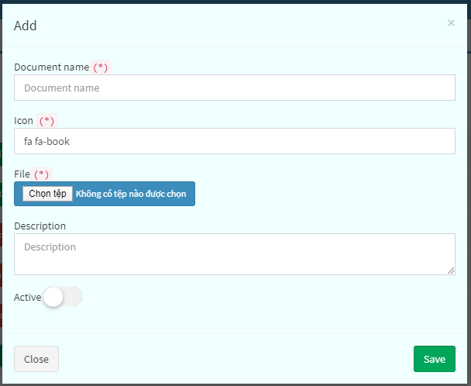

* Edit: click edit button

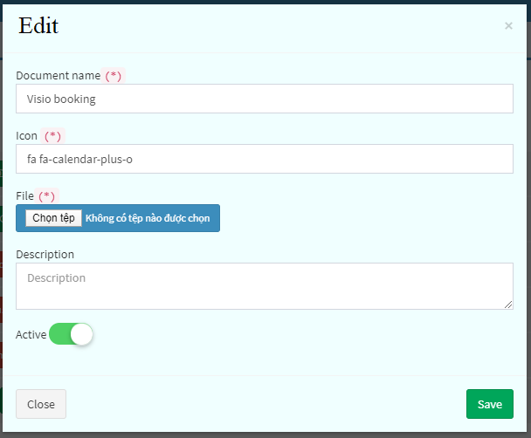

Input the data you want to change, after that, click the Save button to complete

* Delete

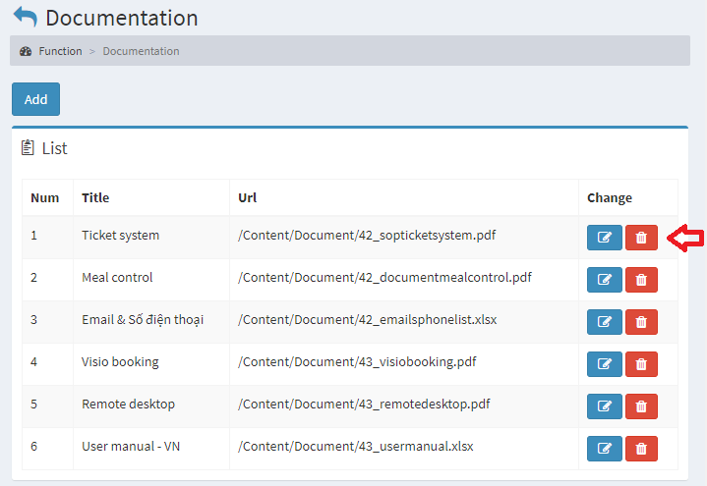

Choose the row data you want to delete, after that click Delete icon on the row, the system will

be remove this row

1. Event

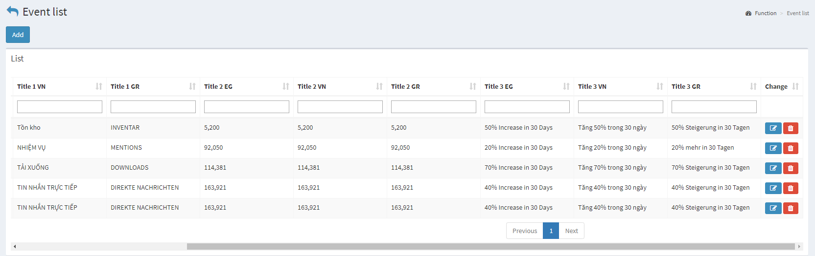

In there, the screen will be showing all event list and you can add new, update or delete data

* Add new: click Add button.

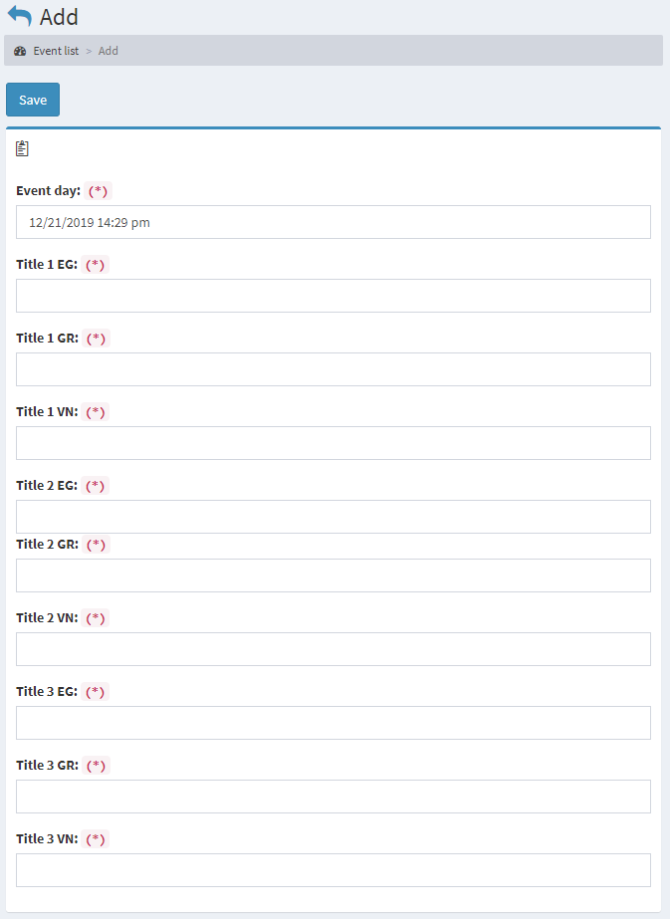

Input event day and title

After that click Save to complete

* Edit

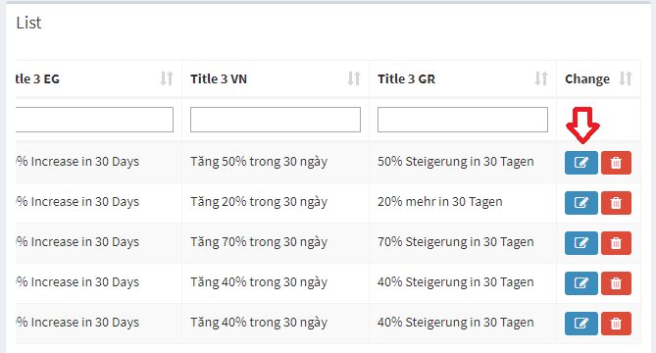

If you want to edit data, Click edit icon, after that, the system will be going to edit page

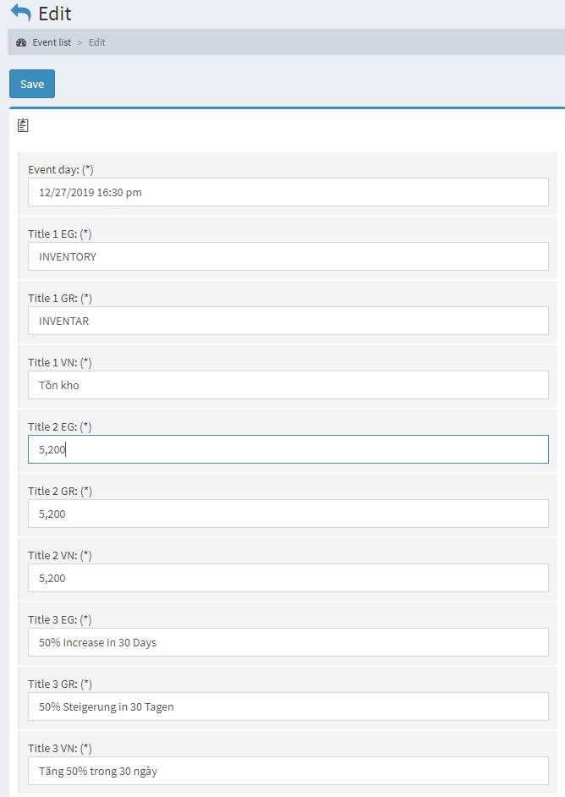

In there, input the data do you want to change

After that click Save to complete

* Delete

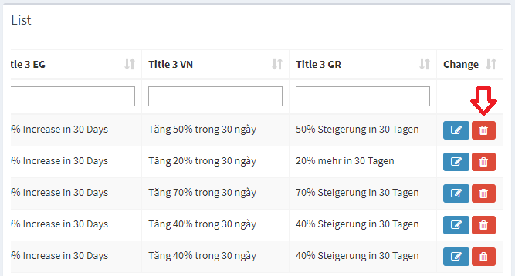

If you want to remove data, Click delete icon on the row you want

1. News

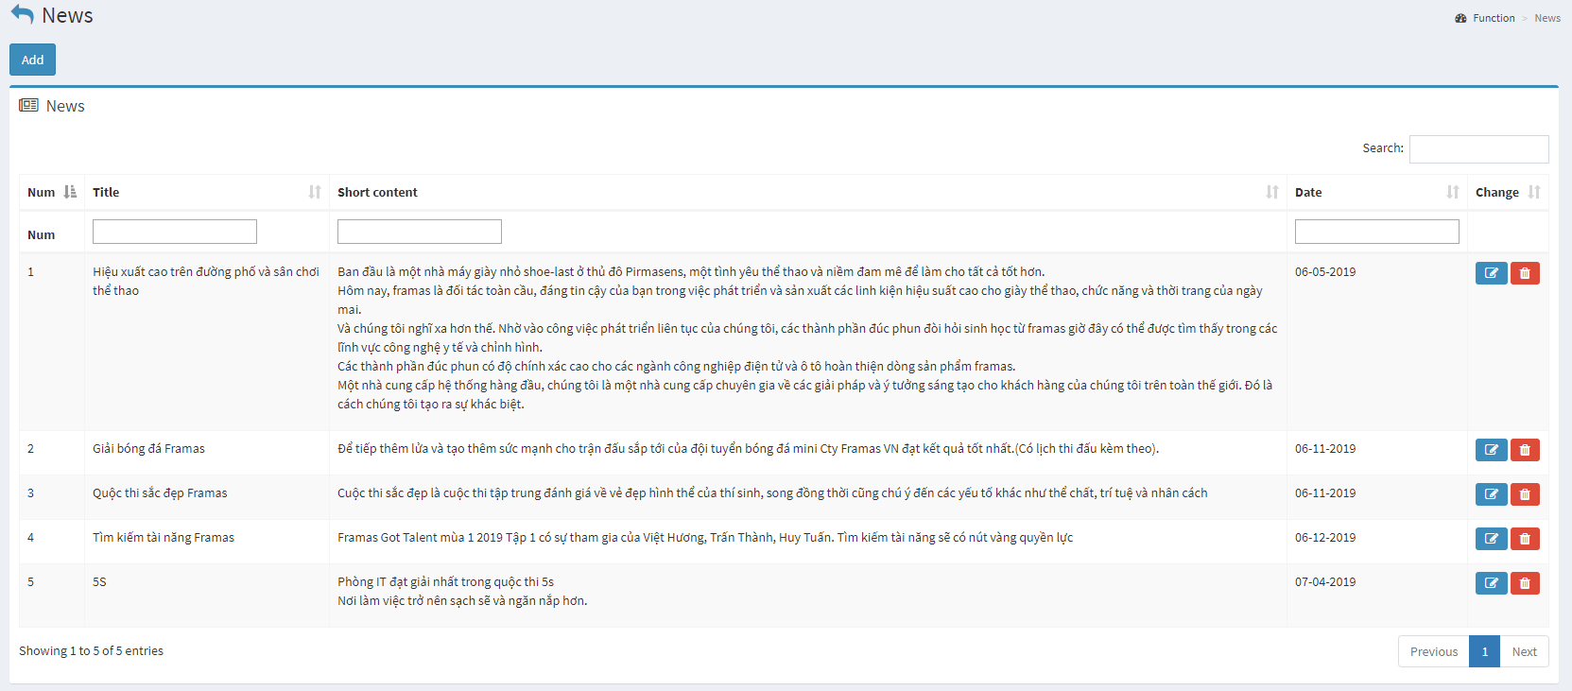

In there, the system will be showing News list and the user can add new, update or delete data

- Add new the News

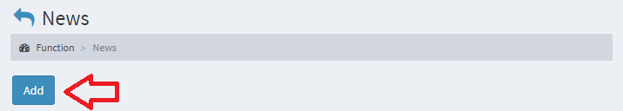

Click the add button, after that the system will be going to the add new page

Type title, short content, content, choose an image from your computer, input News types such as sort news or long news. After that, click Save to complete

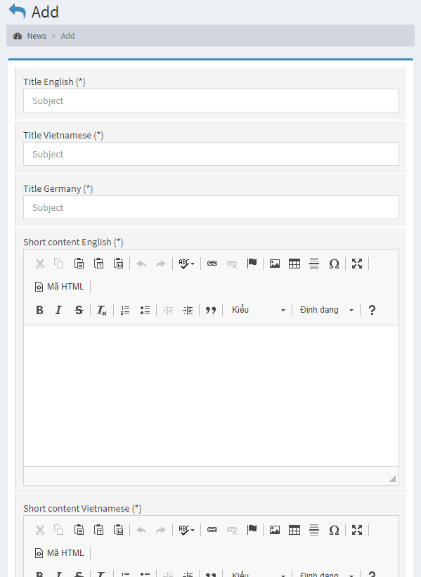

* Edit

Click the edit icon on the row you want, after that, the system will be going to the edit page.

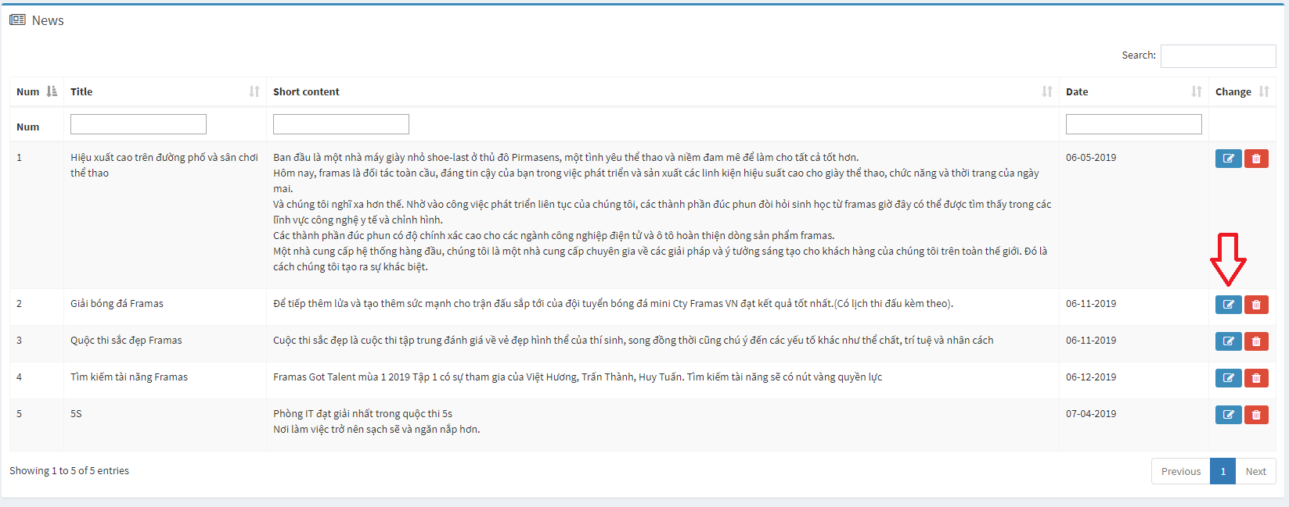

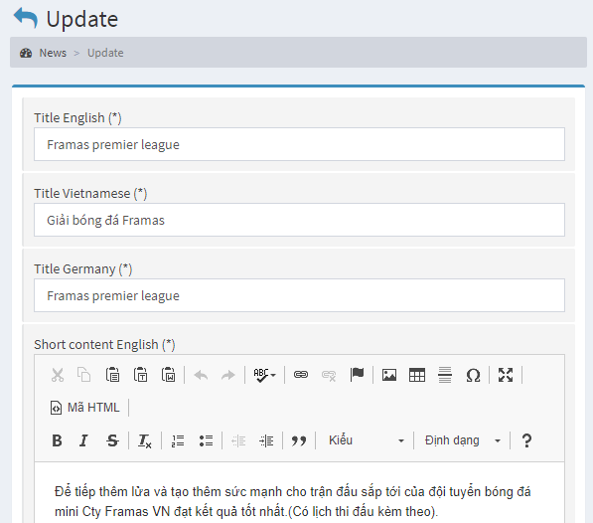

In there, input the data do you want to change after that click save to complete

* Delete

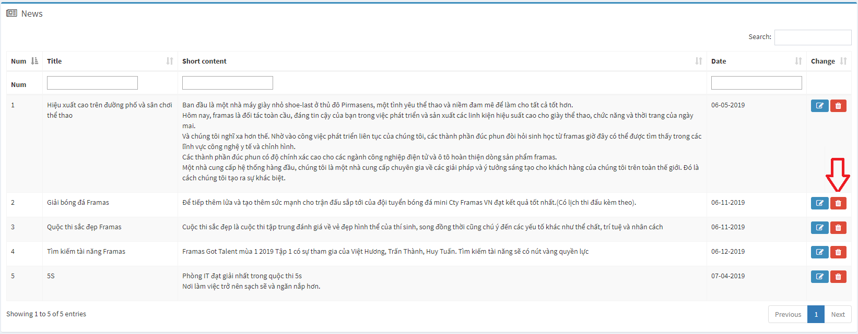

If you want to remove data, Click delete icon on the row you want

1. Slither

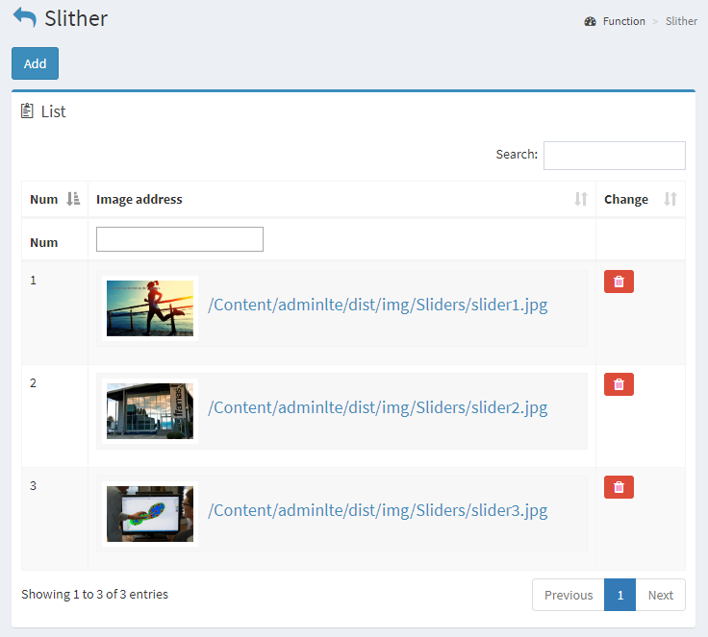

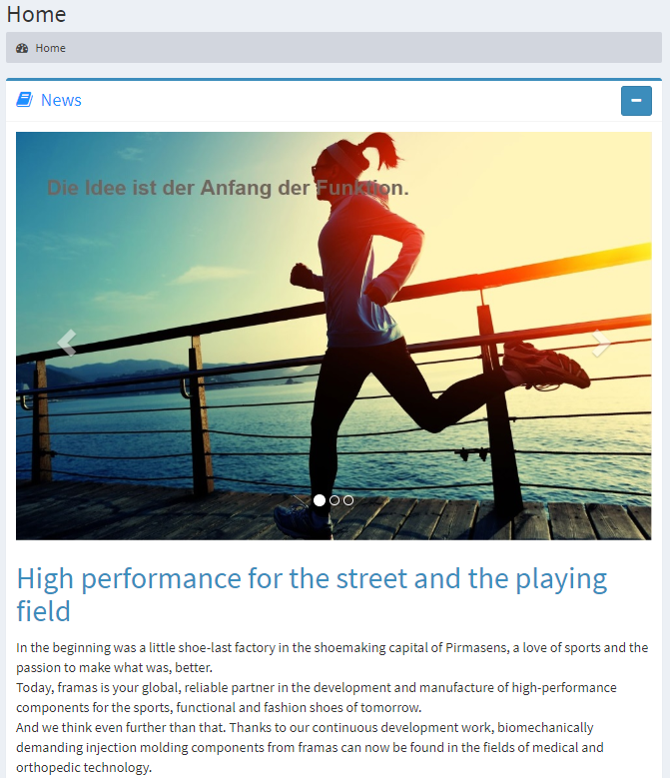

In there, this screen will be showing all images list, and you can add a new or delete the image you want to remove.

* Add new: click Add button, after that, the system will be going to add a new page

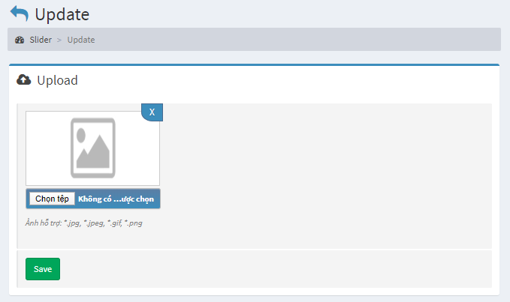

Choose an image and click save to complete

* Delete

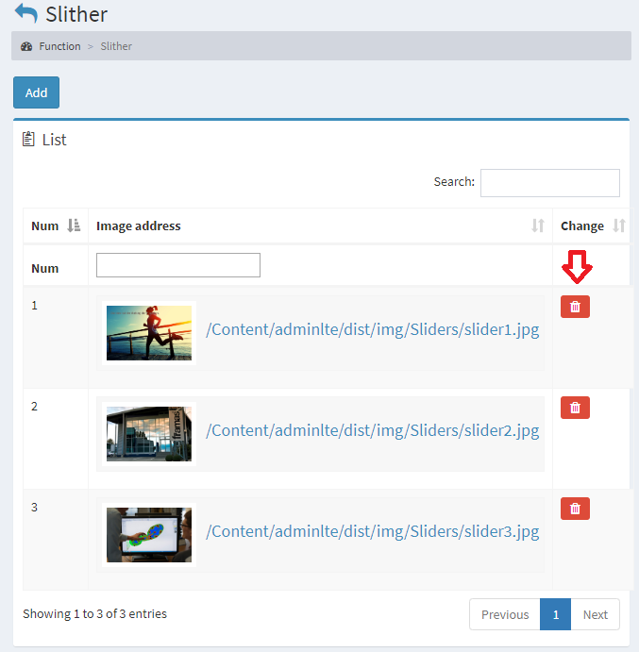

Choose the image you want to delete and click the delete button.

Thanks for reading